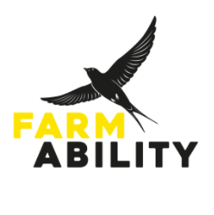
Impact, Monitoring and Pathways Lead

Location: TBC, site within 15 miles of Oxford, main office Eynsham
Hours: 22.5 Hours (0.6 FTE)
Salary: £17,400 (£29,000 FTE pro rata)
Contract: 3 years fixed term as part of the National Lottery funded FarmAbility Foundations Project
Reports to: CEO
Reports: None
Annual Leave: 25 days + bank holidays (pro rata)

FarmAbility is a local independent charity that is committed to improving the quality of lives through access to meaningful activities for adults who have a learning disability. We deliver farming and horticultural-based programmes in partnership with community-based and local farms and gardens. These programmes offer people who have a learning disability the opportunity to engage in daily purposeful activities that not only improve physical and mental health and wellbeing, but also foster a sense of community, and allow the development and strengthening of their skills and abilities.

We are recruiting to a new, national lottery funded role, which will be pivotal to developing a comprehensive approach to outcome monitoring for our organisation. We are looking for somebody with enthusiasm for delving into the how? why? and so what? of what we do! We want to assess how we work, what difference it makes and how we could do better so we can build a long lasting, resilient and above all useful service for the people we exist to support.
This role will also have a hands-on delivery element, working on a tailored basis with individual co-farmers to explore opportunities for pathways into skills development, volunteering, work experience and paid employment, both inside and outside our service. It’s a multi-faceted role with plenty of opportunities to grow and develop.
FarmAbility is a warm and friendly place to work and we put a lot of store on creating strong team relationships and a flexible, accommodating work environment. All staff share our goal of a more inclusive society and a determination to enable co-farmers to achieve positive outcomes and experiences within our service.

To find out more and apply go to: Vacancies – FarmAbility

