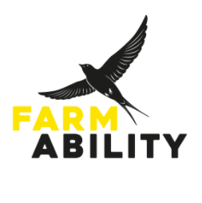
Job Advert: Programme Leader, Part Time
Location Various locations within 15 mile radius of Oxford
Hours Part time, FTE 0.4 or 0.6 = 15 or 22.5hrs p/w
Salary £25,700 (FTE)
Contract Fixed term 12 months with intention to extend subject to funding
Reports to Programme Manager
Reports None
Annual Leave 25 days + bank holidays (pro rata)
FarmAbility is a local independent charity that is committed to improving the quality of lives through access to meaningful activities for adults who have a learning disability. We deliver farming and horticultural-based programmes in partnership with community-based and local farms and gardens. These programmes offer people who have a learning disability the opportunity to engage in daily purposeful activities that not only improve physical and mental health and wellbeing, but also foster a sense of community, and allow the development and strengthening of their skills and abilities.

We are looking for an enthusiastic and motivated individual to join our dedicated team of Programme Leaders. Programme Leaders work with colleagues to plan and deliver day to day tasks on our farm sites for our co-farmers to participate in. They are responsible for supporting co-farmers in a range of purposeful outdoor activities, enabling them to engage increasingly effectively, with the aim of developing skills and capacities. This support leads to greater enjoyment, increased confidence, better physical and mental health and more independence for our participants. The backgrounds of our Programme Leader team are very varied, with people coming to work with us from all sorts of professional and personal experience. The thing that they all have in common is an enthusiasm for our work, a commitment to delivering fulfilling and varied experiences and a passion for sharing their knowledge and expertise in the most inclusive way possible.

To find out more and apply go to: Vacancies – FarmAbility

