Growing with Schools
Companion Planting
Companion plants are beneficial in some way to the main crop. They might repel pests or diseases, attract pollinating insects or insects that prey on pests. Some work on a chemical level in the soil, preventing disease or repelling organisms. They are a safe and organic alternative to pesticides and herbicides, although it might take a bit of trial and error to find combinations that work for you. These are the main ways companion planting is used in the vegetable garden:
Trap Crops
Or ‘sacrificial’ crops. These are plants which prove more attractive to pests than your vegetables and are devoured instead.
Fertiliser Crops
Green manures (plants grown because they improve the soil when dug into it) are increasingly popular and some plants (such as beans and peas) fertilise the soil around them while they are growing, by taking nitrogen from the air, storing it in their roots then releasing it into the surrounding soil for use.
Biochemical Pest Control
Plants might mask the smell of crops to predators, or confuse them enough to make them give up. Some plants exude chemicals from their roots or other parts that suppress or repel pests, to the benefit of neighbouring plants too.
Nurse Crops
Some plants simply provide a bit of shade for tender, smaller plants or a windbreak to protect them. This spatial interaction might also disorientate some insect pests and make it more difficult for them to locate the plants they are after. It also allows you to grow more in a smaller space.
Beneficial Habitat Planting
Some plants provide a refuge for beneficial predatory insects or a food source for their young. They, in turn, keep pest numbers on your crops to a manageable level.
Diversity
Choosing a wide variety of crops will increase your chances of success, provide a mixed environment for insects and enable you to see what grows well in your particular conditions. Planting different varieties of the same vegetable means that some may succeed where others fail. It may also serve to confuse pests. A university study showed that where different cultivars of broccoli were planted together, the instances of green fly infestation was reduced throughout.

Some Companion Planting to Try
Planting one half of a crop alone and one with a beneficial companion creates an opportunity for classes to collect data and compare results. A third section could be planted with a randomly selected plant that is neither beneficial nor harmful.
Marigolds
The flowers of all marigolds attract bees, hover flies and other pollinating insects, which increases your yield. The hover fly larvae then hoover up all the aphids. Plant them all over the garden. Do the same with Nasturtiums (also irresistible to aphids, so use as a trap crop) and Poached Egg Plant. Both also attract nectar-feeding insects.
African Marigolds produce thiopene, which repels nematodes, so is good alongside root crops. White fly are repelled by French Marigolds, so plant near tomatoes. They can also be used as a sacrificial plant to detract the slugs away from your green, leafy veg. English Marigolds (calendula) attract hover flies. Mexican Marigold (Muster-John-Henry) is grown as an annual. Sow seeds inside and plant out in May, after the frosts. It grows to just over a metre high but needs a long growing period to flower (but this doesn’t matter when grown for this purpose). Its roots secrete a substance that repels harmful nematodes and keeled slugs and also inhibits the growth of weeds such as ground elder, couch grass and bindweed.
Beans and Peas
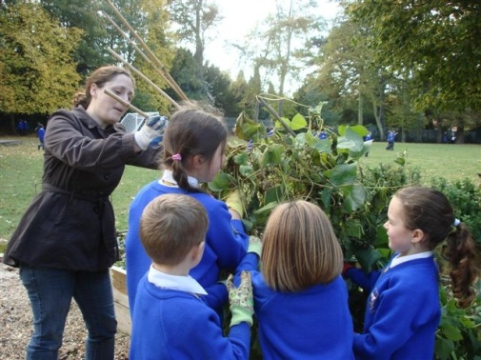
All of the legumes ‘fix’ nitrogen from the air and release it into the soil. Always leave the roots in the ground when removing your old crop. Other plants can be used as green manures, too. Mustard, red clover, alfalfa can all be grown from seed then dug in before they flower to enrich the soil and improve its structure. They can be planted between crop rows or used as a living mulch over winter.
Comfrey
Although it is of use only when cut (and not strictly a companion planting) comfrey is worth a mention as a valuable free fertiliser. Grow it in a neglected corner and make the leaves into a mulch or a tea (rotted down in a bucket or watering can with some rain water). Dilute it and use it like a tomato feed. If you don’t want it spreading everywhere, use the variety Bocking 14, which doesn’t go to seed.
Onions and Garlic
Simply planting alternate rows of carrots and onions or garlic is said to repel carrot root fly.

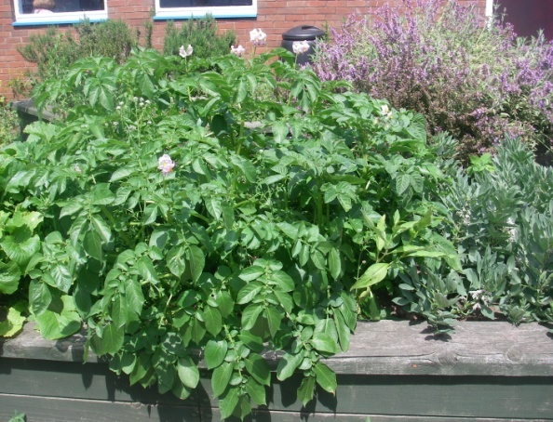
Herbs
Sage, oregano, rosemary, chives, parsley, lavender and lemon balm all benefit the plants around them in different ways. Grow them in pots so that you can move them to where they are needed most.
Place sage near cabbages, oregano with cucumber and squash, rosemary near carrots, chives by tomatoes and carrots, parsley is good for asparagus and tomatoes, lavender is particularly good near fruit trees and lemon balm works in the same way as citronella, deterring bugs, but still attracts bees to its tiny flowers.
A lot of herbs deter pests but many also enhance the growth and productivity of the plants around them. Tomatoes are supposed to crop better when planted with basil. Onions planted with strawberries are supposed to help them fight disease. Lovage is said to improve most plants.
Trap Crops:
Plant mustard near brassicas (cabbage, broccoli, Brussels sprouts, cauliflower, etc) to save them from many insect pests.
Plant extra of any crop to allow for losses.
Nurse Crops
The ‘Three Sisters’ system is a smart use of space and provides the plants with enhanced growing conditions. You need a tall, self supporting plant, a climber and a ground covering plant. The first provides some shelter and all the support for the climber. Traditionally they are sweetcorn, squash and a bean. The climber (if it is a legume) adds nutrients to the soil that the other two can use and the ground cover plant helps suppress weeds. This was a Native American system.

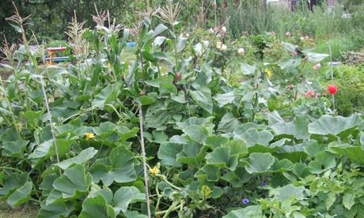
Start them off indoors from seed in pots in March. Plant out the tall one and the ground cover one when strong enough, around May time, adding plenty of manure or home-made compost to ensure they have enough nutrients (especially as they are planted much closer together than usual). Add the climber as a couple of seedlings a short distance from the base of your tall one and between it and the ground cover plant, a week or two later. If it starts to look a bit precarious, add a bamboo cane as extra support. The beans should be ready to harvest first, the sweetcorn second and the squash is then allowed to take over and finish growing with the added nutrient from the bean roots. Experiment with different plant combinations.

Support Plant | Ground Cover | Climber
Sweetcorn (eg. Rising Sun, Sundance) | Courgette (eg. Soleil, Eight Ball, Partenon) | French Bean (eg Blue Lake, Cobra, Golden Gate)
Lovage | Squash ( eg. baby bear, turk’s turban, onion, spaghetti) | Runner Bean (eg. Galaxy, Painted Lady)
Sunflower (eg. Giant sungold, Skyscraper, Henri Wilde) | Compact Bush Tomato (eg. Red alert, Hundreds and Thousands) | Mini Trailing Cucumber (eg. Gherkin, Green Fingers)
Globe Artichoke(eg. Emerald) | Pumpkin (eg. Orbit) | Pea (eg. Alderman, mange tout)

Other Companions
Attracting beneficial wildlife is a rewarding way of protecting your crops. Nest boxes for insect-eating birds and bats, shelter for lacewings and lady birds and other predatory insects and cover for frogs and toads will encourage them to help you out.

